Software Automation Engineering Team

Desk Procedure for Configuring Detailed Powershell Logging

Document Owner: Richard M. Williams

Editor: Richard M. Williams
Document name: Desk Procedure for Configuring Detailed Powershell Logging.doc
Document Revision Number: v1.0
Date: 09-11-15
Document Status: Complete

Version Control
Version | Date | Author | Changes
1.0 | 9-11-2015 | Richard M. Williams | Original Version

1) goto START \ RUN and then type "gpedit.msc" without the quotes - click OK.

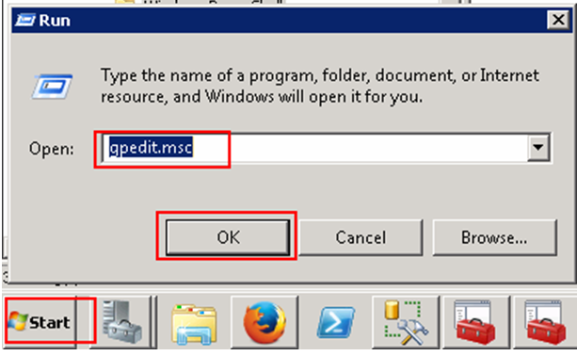

2) go to COMPUTER CONFIGURATION \ ADMINISTRATIVE TEMPLATES \ WINDOWS COMPONENTS \ WINDOWS POWERSHELL

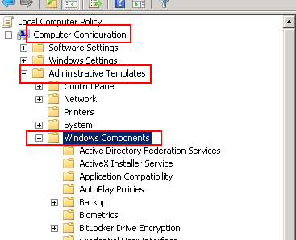

3) click the ENABLED radio button and then click the SHOW button.

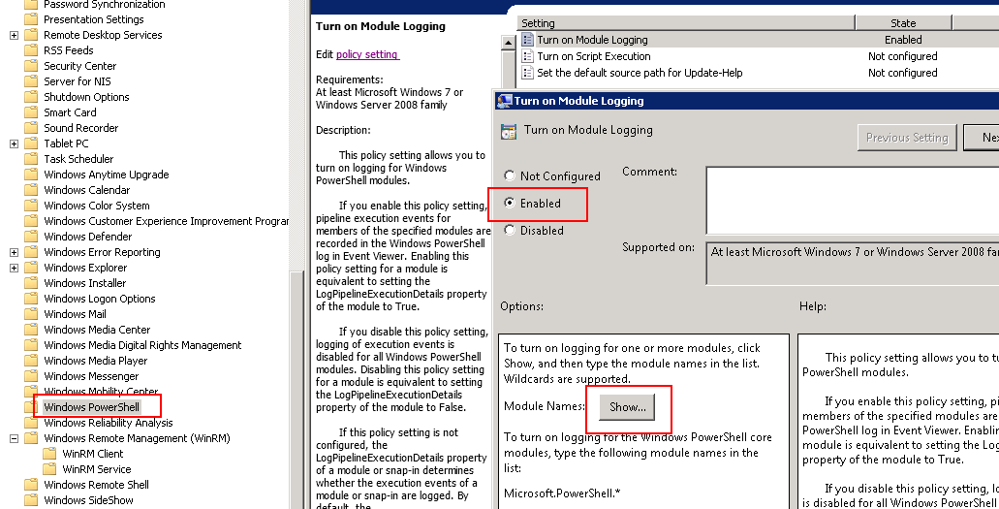

4) Now, enter the following 2 values and then click the OK button.

Microsoft.Powershell.*
Microsoft.WSMAN.Management

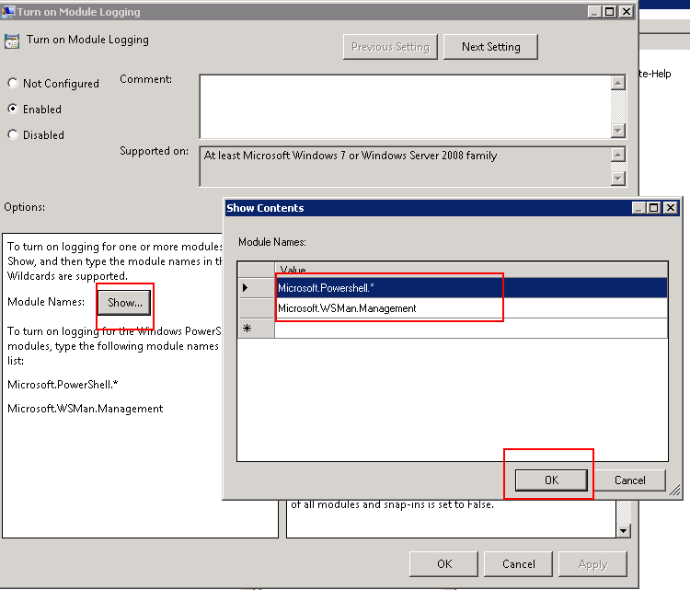

5) Now repeat steps 2-4 for the USER CONFIGURATION section under USER CONFIGURATION \ ADMINISTRATIVE TEMPLATES \ WINDOWS COMPONENTS \ WINDOWS POWERSHELL

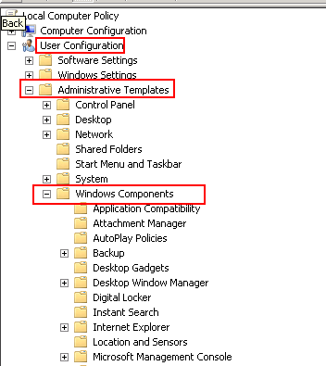

6) Next, go to START and right-click on COMPUTER and then select MANAGE.

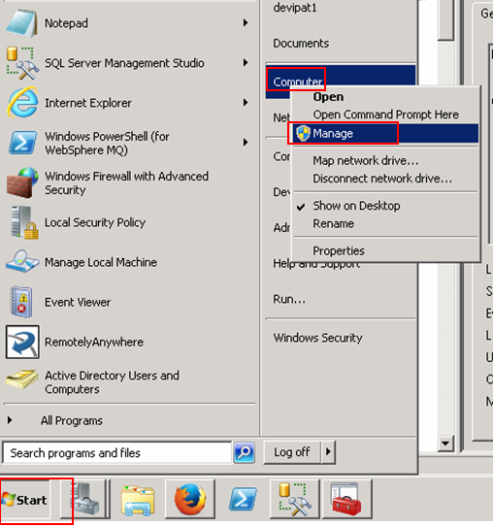

7) Under the EVENT VIEWER section, right-click on WINDOWS LOGS and then click VIEW and then click SHOW ANALYTIC AND DEBUG LOGS.

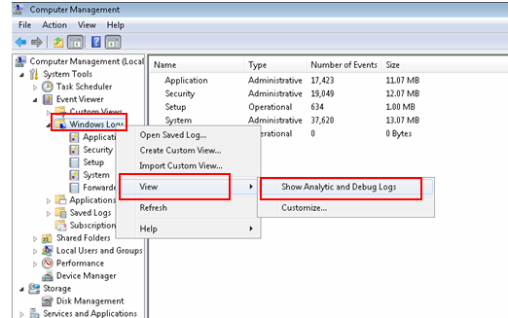

8) Now, under the EVENT VIEWER folder, click on APPLICATIONS AND SERVICES LOGS \ MICROSOFT \ WINDOWS \ POWERSHELL.....

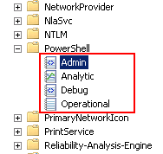

9) Next, right-click on the various sub-folders (Admin \ Analytic \ Debug \ Operational) and select ENABLE LOG

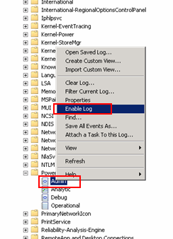

References:

http://windowsitpro.com/blog/tools-troubleshooting-powershell-remoting-and-winrm-part-2

https://social.technet.microsoft.com/Forums/windowsserver/en-US/7f8cb64d-5072-4082-af45-31315439d4c8/powershell-logs

https://www.petri.com/enable-powershell-logging

https://www.reddit.com/r/PowerShell/comments/3ebgnr/possible_to_get_log_of_remote_powershell_commands/

https://technet.microsoft.com/en-us/library/hh847797.aspx

http://hackerhurricane.blogspot.com/2014/11/i-powershell-logging-what-everyone.html

